SMTP Client

📬 What is an SMTP Client?
# Source: AI Source: Provided by: [Data Path: Persons Table -> ID Column: 1, Name_En Column: Motasem Essam] -> From: [ChatGPT] on [1/21/2026]
An SMTP client is a software or tool that sends emails using the SMTP (Simple Mail Transfer Protocol). It connects to an SMTP server and delivers your email messages to it, which then forwards them to the recipient’s email server.

🧠 Think of it like this:
# Source: AI Source: Provided by: [Data Path: Persons Table -> ID Column: 1, Name_En Column: Motasem Essam] -> From: [ChatGPT] on [1/21/2026]
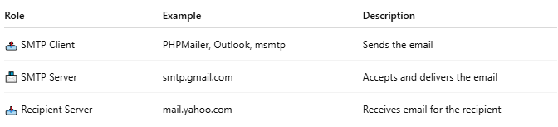

Role | Example | Description
📤 SMTP Client | PHPMailer, Outlook, msmtp | Sends the email
📨 SMTP Server | smtp.gmail.com | Accepts and delivers the email
📥 Recipient Server | mail.yahoo.com | Receives email for the recipient

✅ Examples of SMTP Clients
# Source: AI Source: Provided by: [Data Path: Persons Table -> ID Column: 1, Name_En Column: Motasem Essam] -> From: [ChatGPT] on [1/21/2026]
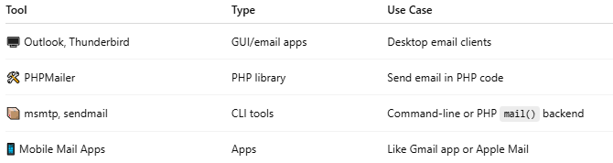

Tool | Type | Use Case
🖥️ Outlook, Thunderbird | GUI/email apps | Desktop email clients
🛠 PHPMailer | PHP library | Send email in PHP code
📦 msmtp, sendmail | CLI tools | Command-line or PHP mail() backend
📱 Mobile Mail Apps | Apps | Like Gmail app or Apple Mail

📡 What an SMTP client does:
# Source: AI Source: Provided by: [Data Path: Persons Table -> ID Column: 1, Name_En Column: Motasem Essam] -> From: [ChatGPT] on [1/21/2026]
- Connects to an SMTP server (e.g., smtp.gmail.com)
- Authenticates (username/password or App Password)
- Sends the email headers, body, attachments
- The server accepts it and forwards to the recipient

🔒 Optional Features:
# Source: AI Source: Provided by: [Data Path: Persons Table -> ID Column: 1, Name_En Column: Motasem Essam] -> From: [ChatGPT] on [1/21/2026]
- TLS/SSL encryption
- Authentication (SMTP AUTH)
- Queueing
- Retry logic

🔁 Example Flow with PHPMailer (SMTP client):
# Source: AI Source: Provided by: [Data Path: Persons Table -> ID Column: 1, Name_En Column: Motasem Essam] -> From: [ChatGPT] on [1/21/2026]
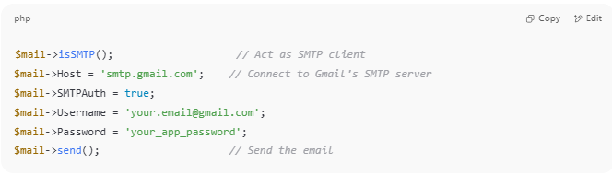

$mail->isSMTP(); // Act as SMTP client
$mail->Host = 'smtp.gmail.com'; // Connect to Gmail's SMTP server
$mail->SMTPAuth = true;
$mail->Username = 'your.email@gmail.com';
$mail->Password = 'your_app_password';
$mail->send(); // Send the email

🔧 Why use an SMTP client?
# Source: AI Source: Provided by: [Data Path: Persons Table -> ID Column: 1, Name_En Column: Motasem Essam] -> From: [ChatGPT] on [1/21/2026]
- To send emails from apps, servers, or scripts
- To integrate email into your PHP, Python, or Node.js code
- To avoid running your own mail server

